Department of Information Engineering Technology The Superior University, Lahore

Mobile Application Development Lab

Experiment No.10
Flutter: Cards, Lists, Grids, and Slivers Widgets
Prepared for

Eisha Nawaz

By:
Name: iqra

ID: SU91-BIETM-F23-030

Section: A

Semester: 6

Total Marks: 10

Obtained Marks:

Signature:

Date:

Experiment No.10

Flutter: Cards, Lists, Grids, and Slivers Widgets
(Rubrics)

Name: Iqra Roll No: SU91-BIETM-F23-030
- PSYCHOMOTOR

Sr.  No. | Criteria | Allocated Marks | Unacceptable  0% | Poor  25% | Fair  50% | Good  75% | Excellent  100% | Total Obtained
1 | Follow Procedures | 1 | 0 | 0.25 | 0.5 | 0.75 | 1
2 | Software and Simulations | 2 | 0 | 0.5 | 1 | 1.5 | 2
3 | Accuracy in Output Results | 3 | 0 | 0.75 | 1.5 | 2.25 | 3
Sub Total |  | 6 | Sub Total marks Obtained in Psychomotor(P)

- AFFECTIVE

Sr.  No. | Criteria | Allocated Marks | Unacceptable  0% | Poor  25% | Fair  50% | Good  75% | Excellent  100% | Total Obtained
1 | Respond to Questions | 1 | 0 | 0.25 | 0.5 | 0.75 | 1
2 | Lab Report | 1 | 0 | 0.25 | 0.5 | 0.75 | 1
3 | Assigned Task | 2 | 0 | 0.5 | 1 | 1.5 | 2
Sub Total |  | 4 | Sub Total marks Obtained in Affective (A)

Instructor Name: Eisha Nawaz Total Marks (P+A): 10

Instructor Signature: Obtained Marks (P+A):

USING THE CARD
The Card widget is part of the Material Design and has minimal rounded corners and shadows. To group and lay out data, the Card is a perfect widget to enhance the look of the UI. The Card widget is customizable with properties such as elevation, shape, color, margin, and others. The elevation property is a value of double, and the higher the number, the larger the shadow that
is cast. Some of the shape properties are StadiumBorder, Underline­ InputBorder, OutlineInputBorder, and others.
Card(
elevation: 8.0, color: Colors.white,
margin: EdgeInsets.all(16.0), child: Column(
mainAxisAlignment: MainAxisAlignment.center, children: <Widget>[
Text('
'Barista',
textAlign: TextAlign.center, style: TextStyle(
fontWeight: FontWeight.bold, fontSize: 48.0,
color: Colors.orange,
), '),
Text(
'Travel Plans',
textAlign: TextAlign.center,
style: TextStyle(color: Colors.grey),
),
],
),
),
The following are a few ways to customize the Card’s shape property (Figure 9.1):
// Create a Stadium Border shape: StadiumBorder(),

// Create Square Corners Card with a Single Orange Bottom Border
shape: UnderlineInputBorder(borderSide: BorderSide(color: Colors.deepOrange)),

// Create Rounded Corners Card with Orange Border
shape: OutlineInputBorder(borderSide: BorderSide(color: Colors.deepOrange. withOpacity(0.5)),),

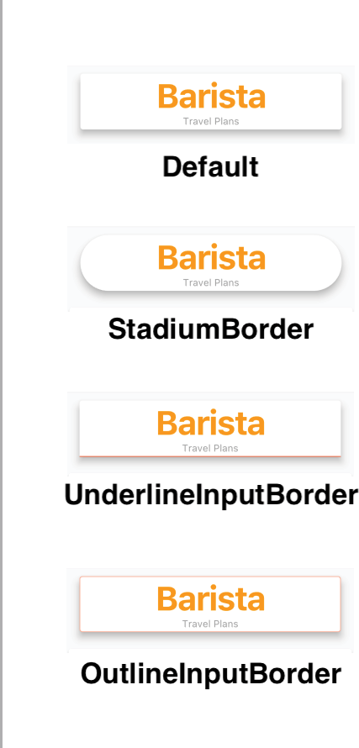

FIGURE 9.1: Card customizat

USING THE LISTVIEW AND LISTTILE
The constructor ListView.builder is used to create an on-demand linear scrollable list of widgets (Figure 9.2). When you have a large set of data, the builder is called only for visible widgets, which is great for performance. Within the builder, you use the itemBuilder callback to create the list of children widgets. Keep in mind the itemBuilder is called only if the itemCount argument is greater than zero, and it is called as many times as the itemCount value. Remember, the List starts at row 0, not 1. If you have 20 items in the List, it loops from row 0 to 19. The scrollDirection argument defaults to Axis.vertical but can be changed to Axis.horizontal.
The ListTile widget is commonly used with the
ListView widget to easily format and organize icons, titles, and descriptions in a linear layout. Among the main proper- ties are leading, trailing, title, and subtitle proper- ties, but there are others. You can also use the onTap and onLongPress callbacks to execute an action when the user taps the ListTile. Usually the leading and trailing prop- erties are implemented with icons, but you can add any type of widget.

In Figure 9.2, the first three ListTiles show an icon for the leading property, but for the trailing property, a Text widget shows a percentage value. The remaining ListTiles show both the leading and trailing properties as icons. Another scenario is to use the subtitle property to show a progress bar instead of additional text description since these properties accept widgets.
The first code example here shows a Card with the child property as a ListTile to give it a nice frame and shadow effect. The second example shows a base ListTile.
// Card with a ListTile widget Card(
child: ListTile(
leading: Icon(Icons.flight), title: Text('Airplane $index'), subtitle: Text('Very Cool'), trailing: Text('${index * 7}%'),
onTap: ()=> print('Tapped on Row $index'),
),
);

FIGURE 9.2: ListView linear layout using the ListTile
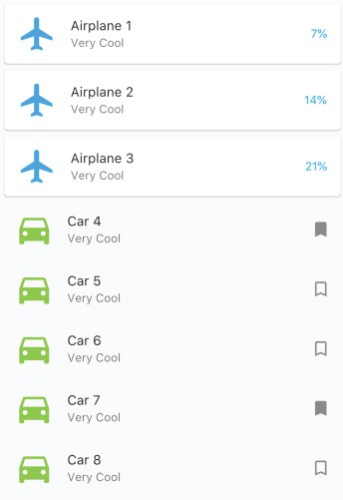

// ListTile ListTile(
leading: Icon(Icons.directions_car), title: Text('Car $index'),
subtitle: Text('Very Cool'), trailing: Icon(Icons.bookmark),
onTap: ()=> print('Tapped on Row $index'),
);

TRY IT OUT Creating the ListView App
In this example, the ListView widget uses the builder to display a Card for the header and two varia- tions of the ListTile for the data list. The ListTile can display leading and trailing widgets. The leading property shows an Icon but could have displayed an Image. For the trailing property, the first type of ListTile shows data as a percentage, and the second ListTile shows a selected or unse- lected bookmark Icon. You also set a title and subtitle, and for the onTap you use the print state- ment to show the tapped row index value.

- Create a new Flutter project and name it ch9_listview. You can follow the instructions in Chapter 4, “Creating a Starter Project Template.” For this project, you need to create only the pages and widgets folders. Create the Home Class as a StatelessWidget since the data does not require changes.
- Open the home.dart file and add to the body a SafeArea with ListView.builder() as a child. body: SafeArea(
child: ListView.builder(),
),
- Set the ListView.builder with the itemCount argument set to 20. For this example, you specify 20 rows of data. For the itemBuilder callback, it passes the BuildContext and the widget index as an int value.
To show how to create different types of widgets to list each row of data, let’s check the first row for the index value of zero and call the HeaderWidget(index: index) widget class. This class shows a Card with the text “Barista Travel Plan.”
For the first, second, and third rows, the widget class RowWithCardWidget(index: index) is called to show a ListTile as a child of a Card. For the rest of the rows, you call the RowWidget(index: index) widget class to show a default ListTile.
It’s important to understand that the widget classes you call from the itemBuilder create a unique widget with the index value passed. The itemBuilder loops the itemCount value, in this exam- ple 20 times.
You’ll create the three widget classes in step 5.
body: SafeArea(
child: ListView.builder( itemCount: 20,
itemBuilder: (BuildContext context, int index) { if (index == 0) {
return HeaderWidget(index: index);
} else if (index >= 1 && index <= 3) { return RowWithCardWidget(index: index);
} else {
return RowWidget(index: index);
}

},
),
),

- Add to the top of the file the import statements for the header.dart, row_with_card.dart, and
row.dart widget classes that you’ll create next.
import 'package:flutter/material.dart';
import 'package:ch9_listview/widgets/header.dart';
import 'package:ch9_listview/widgets/row_with_card.dart'; import 'package:ch9_listview/widgets/row.dart';
- Create a new Dart file in the widgets folder. Right-click the widgets folder and then select New ➪
Dart File, enter header.dart, and click the OK button to save.
- Import the material.dart library, add a new line, and then start typing st; the autocompletion help opens, so select the stless (StatelessWidget) abbreviation and give it a name of HeaderWidget.
- Modify the HeaderWidget widget class to return a Container. Import the material.dart library.
The Container child is a Card with an elevation of 8.0 to show a deep shadow. The Card children list of widgets returns two Text widgets. I purposely left three shape types commented out for you to test and see how they change the shape and borders of the Card.
I wanted to point out that the ListView itemBuilder in the main.dart file calls this class, the HeaderWidget(index: index) for each row item. For every row, a Widget is created and added to the widget tree.
Note I commented out three different ways to customize the default Card shape for your testing.
import 'package:flutter/material.dart';

class HeaderWidget extends StatelessWidget { const HeaderWidget({
Key key,
@required this.index,
}) : super(key: key); final int index;
@override
Widget build(BuildContext context) { return Container(
padding: EdgeInsets.all(16.0), height: 120.0,
child: Card( elevation: 8.0, color: Colors.white,
//shape: StadiumBorder(),
//shape: UnderlineInputBorder(borderSide: BorderSide(color: Colors
.deepOrange)),
//shape: OutlineInputBorder(borderSide: BorderSide(color: Colors.deepOrange.withOpacity(0.5)),),
child: Column(
mainAxisAlignment: MainAxisAlignment.center, children: <Widget>[
Text(
'Barista',
textAlign: TextAlign.center, style: TextStyle(
fontWeight: FontWeight.bold, fontSize: 48.0,
color: Colors.orange,
),
),
Text(
'Travel Plans',
textAlign: TextAlign.center,
style: TextStyle(color: Colors.grey),
),
],

),
),
);
}
}
- Create a new Dart file in the widgets folder. Right-click the widgets folder and then select New ➪
Dart File, enter row_with_card.dart, and click the OK button to save.
- Import the material.dart library, add a new line, and then start typing st; the autocompletion help opens, so select the stless (StatelessWidget) abbreviation and give it a name of RowWithCardWidget.
- Modify the RowWithCardWidget class widget to return a Card. Import the material.dart library.
The Card child is a ListTile, which is great to align content easily. For the leading property, return an Icon. The trailing property returns a Text widget with string interpolation that takes the index times seven to obtain a number. The title property returns a Text widget with the index value. The subtitle property returns a Text widget. For the onTap property, you use a print statement to show the tapped row index.
As a reminder, a widget is created and added to the widget tree for each row.
import 'package:flutter/material.dart';

class RowWithCardWidget extends StatelessWidget { const RowWithCardWidget({
Key key,
@required this.index,
}) : super(key: key); final int index;
@override
Widget build(BuildContext context) { return Card(
child: ListTile( leading: Icon(
Icons.flight, size: 48.0,
color: Colors.lightBlue,
),
title: Text('Airplane $index'), subtitle: Text('Very Cool'), trailing: Text(
'${index * 7}%',
style: TextStyle(color: Colors.lightBlue),
),
//selected: true, onTap: () {
print('Tapped on Row $index');
},
),
);
}
}

- Create a new Dart file in the widgets folder. Right-click the widgets folder and then select New ➪
Dart File, enter row.dart, and click the OK button to save.
- Import the material.dart library, add a new line, and then start typing st; the autocompletion help opens, so select the stless (StatelessWidget) abbreviation and give it a name of RowWidget.
- Modify the RowWidget widget class to return a ListTile. Import the material.dart library.
- For the leading property, return an Icon. For the trailing property, you return either a book­ mark_border or a bookmark Icon. To randomize which Icon to return, use a ternary operator to calculate the index modulus (%) of 3 and check whether it’s an even number. If the number is even or odd, the appropriate Icon is shown. The title property returns a Text widget with the index value. The subtitle property returns a Text widget.
For the onTap, you use a print statement to show the tapped row index. Note that for each row a widget is added to the widget tree.
import 'package:flutter/material.dart';

class RowWidget extends StatelessWidget { const RowWidget({
Key key,
@required this.index,
}) : super(key: key); final int index;
@override
Widget build(BuildContext context) { return ListTile(
leading: Icon( Icons.directions_car, size: 48.0,
color: Colors.lightGreen,
),
title: Text('Car $index'), subtitle: Text('Very Cool'), trailing: (index % 3).isEven
? Icon(Icons.bookmark_border)
: Icon(Icons.bookmark), selected: false,
onTap: () {
print('Tapped on Row $index');
},
);
}
}

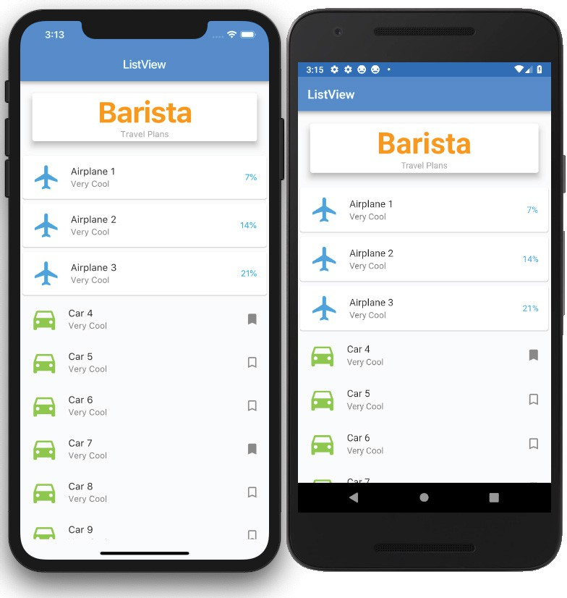

HOW IT WORKS
The ListView.builder constructor takes an itemCount and uses the itemBuilder to build a widget for each child record. Each child widget is added to the widget tree with the appropriate values. As each child widget is added, you can customize the ListView rows according to app specs.
Using the ListTile makes it extremely easy to align widgets. The ListTile takes a leading, trailing, title, subtitle, onTap, and other properties.

USING THE GRIDVIEW
The GridView (Figure 9.3) displays tiles of scrollable widgets in a grid format. The three constructors that I focus on are GridView.count, GridView.extent, and GridView.builder.
The GridView.count and GridView.extent are usually used with a fixed or smaller data set. Using these constructors means that all of the data, not just visible widgets, is loaded at init. If you have a large set of data, the user does not see
the GridView until all data is loaded, which is not a great user experience (UX). Usually you use the GridView.count when you need a layout with a fixed number of tiles in the cross- axis. For example, it shows three tiles in portrait and land- scape modes. You use the GridView.extent when you need
a layout with the tiles that need a maximum cross-axis extent. For example, two to three tiles fit in portrait mode, and five to six tiles fit in landscape mode; in other words, it fits as many tiles that it can depending on screen size.
The GridView.builder constructor is used with a larger, infinite, or unknown size set of data. Like our ListView. builder, when you have a large set of data, the builder is called only for visible widgets, which is great for performance.
Within the builder, you use the itemBuilder callback to create the list of children widgets. Keep in mind the

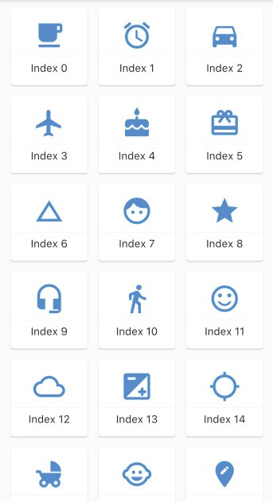
FIGURE 9.3: GridView layout

itemBuilder is called only if the itemCount argument is greater than zero, and it is called as many times as the itemCount value. Remember, the List starts at row 0, not 1. If you have 20 items in the List, it loops from row 0 to 19. The scrollDirection argument defaults to Axis.vertical but can be changed to Axis.horizontal (Figure 9.3).

Using the GridView.count
The GridView.count requires setting the crossAxisCount and the children argument. The crossAxisCount sets the number of tiles to display (Figure 9.4), and children is a list of widgets. The scrollDirection argument sets the main axis direction for the Grid to scroll, either Axis
.vertical or Axis.horizontal, and the default is vertical.
For the children, you use the List.generate to create your sample data, a list of values. Within the children argument, I added a print statement to show that the entire list of values is built at the same time, not just the visible rows like the GridView.builder. Note for the following sample code, 7,000 records are generated to show that the GridView.count does not show any data until all of the records are processed first.
GridView.count( crossAxisCount: 3,
padding: EdgeInsets.all(8.0),

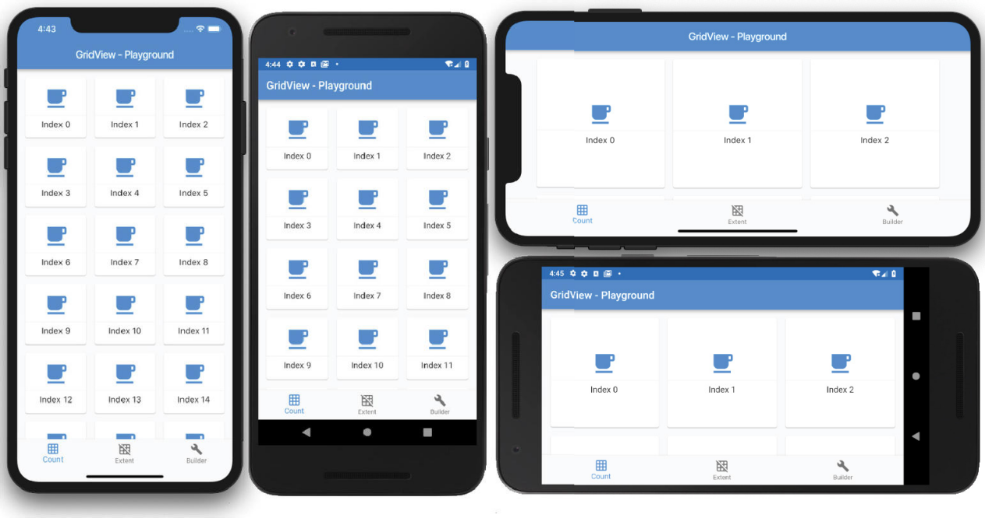
FIGURE 9.4: GridView count with three tiles in portrait and landscape mode

children: List.generate(7000, (index) { print('_buildGridView $index');

return Card(
margin: EdgeInsets.all(8.0), child: InkWell(
child: Column(
mainAxisAlignment: MainAxisAlignment.center, children: <Widget>[
Icon(
_iconList[0], size: 48.0,
color: Colors.blue,
),
Divider(), Text(
'Index $index',
textAlign: TextAlign.center, style: TextStyle(
fontSize: 16.0,
),
)
],
),
onTap: () {
print('Row $index');
},
),
);
},),
)

Using the GridView.extent
The GridView.extent requires you to set the maxCrossAxisExtent and children argument. The maxCrossAxisExtent argument sets the maximum size of each tile for the axis. For example, in portrait, it can fit two to three tiles, but when rotating to landscape, it can fit five to six depending on the screen size (Figure 9.5). The scrollDirection argument sets the main axis direction for the grid to scroll, either Axis.vertical or Axis.horizontal, and the default is vertical.
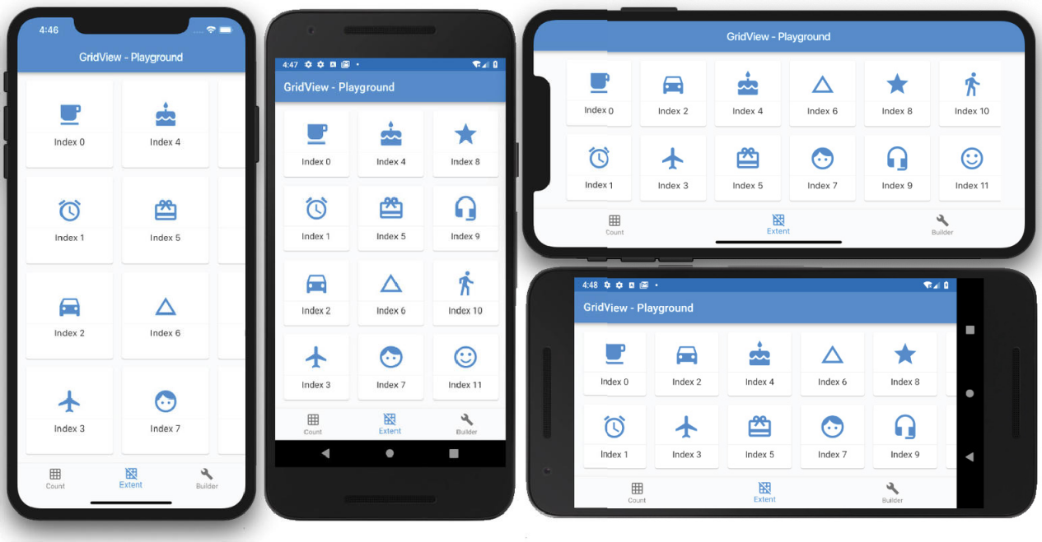
FIGURE 9.5: GridView extent showing the maximum number of tiles that can fit according to screen size

For the children, you use List.generate to create your sample data, which is a list of values. Within the children argument, I added a print statement to show that the entire list of values is built at the same time, not just the visible rows like the GridView.builder.
GridView.extent( maxCrossAxisExtent: 175.0, scrollDirection: Axis.horizontal, padding: EdgeInsets.all(8.0),
children: List.generate(20, (index) { print('_buildGridViewExtent $index');

return Card(
margin: EdgeInsets.all(8.0), child: InkWell(
child: Column(
mainAxisAlignment: MainAxisAlignment.center, children: <Widget>[
Icon(
_iconList[index], size: 48.0,
color: Colors.blue,
),

Divider(), Text(
'Index $index',
textAlign: TextAlign.center, style: TextStyle(
fontSize: 16.0,
),
)
],
),
onTap: () {
print('Row $index');
},
),
);
}),
)

Using the GridView.builder
The GridView.builder requires you to set the itemCount, gridDelegate, and itemBuilder arguments. The itemCount sets the number of tiles to build. The gridDelegate is a SilverGrid­ Delegate responsible for laying out the children list of widgets for the GridView. The gridDelegate argument cannot be null; you need to pass the maxCrossAxisExtent size, for example, 150.0 pixels.
For example, to display three tiles across the screen you specify the gridDelegate argument with the SliverGridDelegateWithFixedCrossAxisCount class to create a grid layout with a fixed number of tiles for the cross axis. If you need to display tiles that have a maximum width of 150.0 pixels, you
specify the gridDelegate argument with the SliverGridDelegateWithMaxCrossAxisExtent class to create a grid layout with tiles that have a maximum cross-axis extent, the maximum width of each tile.
The GridView.builder is used when you have a large set of data because the builder is called only for visible tiles, which is great for performance. Using the GridView.builder constructor results in lazily building a list for visible tiles, and when the user scrolls to the next visible tiles they are lazily built as needed.

TRY IT OUT Creating the GridView.builder App
In this example, the GridView widget uses the builder to display a Card that shows each Grid item with an Icon and a Text showing the index location. The onTap will print the index of the tapped Grid item.
- Create a new Flutter project and name it ch9_gridview, following the instructions in Chapter 4. For this project, you need to create only the pages, classes, and widgets folders. Create the Home Class as a StatelessWidget since the data does not require changes.
- Open the home.dart file and add to the body a SafeArea with the GridViewBuilderWidget()
widget class as a child.
body: SafeArea(
child: const GridViewBuildWidget(),
),

- Add to the top of the file the import statement for the gridview_builder.dart widget class that you’ll create next.
import 'package:flutter/material.dart';
import 'package:ch9_gridview/widgets/gridview_builder.dart';

- Create a new Dart file in the widgets folder. Right-click the classes folder and then select New ➪
Dart File, enter grid_icons.dart, and click the OK button to save.
- Import the material.dart library, add a new line, and create the GridIcons Class. The
GridIcons Class holds a List of IconData called iconList.
- Create the getIconList() method that creates the List of IconData that is used later in the
GridView.builder.
class GridIcons { List<IconData> iconList = [];

List<IconData> getIconList() { iconList
..add(Icons.free_breakfast)
..add(Icons.access_alarms)
..add(Icons.directions_car)
..add(Icons.flight)
..add(Icons.cake)
..add(Icons.card_giftcard)
..add(Icons.change_history)
..add(Icons.face)
..add(Icons.star)
..add(Icons.headset_mic)
..add(Icons.directions_walk)
..add(Icons.sentiment_satisfied)
..add(Icons.cloud_queue)
..add(Icons.exposure)
..add(Icons.gps_not_fixed)
..add(Icons.child_friendly)
..add(Icons.child_care)
..add(Icons.edit_location)
..add(Icons.event_seat)
..add(Icons.lightbulb_outline); return iconList;
}
}
- Create a new Dart file under the widgets folder. Right-click the widgets folder and then select New ➪ Dart File, enter gridview_builder.dart, and click the OK button to save.
- Import the material.dart library, add a new line, and then start typing st; the autocompletion help opens, so select the stless (StatelessWidget) abbreviation and give it a name of GridViewBuilderWidget.
- Modify the GridViewBuilderWidget widget class to return a GridView.builder with the
itemCount argument set to 20. For this example, you specify to list 20 rows of data.

- For the gridDelegate argument, use SliverGridDelegateWithMaxCrossAxisExtent(maxCross AxisExtent: 150.0). Your other option is to use the SliverGridDelegateWithFixedCrossAxisCount instead, which works in the same manner as the GridView.count constructor, where you pass the number of tiles to display.
- For the itemBuilder callback, it passes the BuildContext and the widget index as an int value. In the itemBuilder first line, place a print statement to show each item index being built accord- ing to the visible space.
- Return a Card with the child as an InkWell. The InkWell onTap has a print statement to show the tapped Card item, with the Row selected.
- For the InkWell child property, pass a Column with these children: Icon, Divider, and Text widgets. Note that the itemBuilder is called for each row item. For every row, a Widget is created and added to the widget tree.
The onTap will print the index of the tapped Grid item.
- Add to the top of the file the import statement for the grid_icons.dart class.
import 'package:flutter/material.dart';
import 'package:ch9_gridview/classes/grid_icons.dart';

class GridViewBuilderWidget extends StatelessWidget { const GridViewBuilderWidget({
Key key,
}) : super(key: key);

@override
Widget build(BuildContext context) {
List<IconData> _iconList = GridIcons().getIconList();

return GridView.builder( itemCount: 20,
padding: EdgeInsets.all(8.0),
gridDelegate: SliverGridDelegateWithMaxCrossAxisExtent(maxCrossAxisExtent: 150.0),
itemBuilder: (BuildContext context, int index) { print('_buildGridViewBuilder $index');

return Card(
color: Colors.lightGreen.shade50, margin: EdgeInsets.all(8.0), child: InkWell(
child: Column(
mainAxisAlignment: MainAxisAlignment.center, children: <Widget>[
Icon(
_iconList[index], size: 48.0,
color: Colors.lightGreen,
),
Divider(), Text(

'Index $index',
textAlign: TextAlign.center, style: TextStyle(
fontSize: 16.0,
),
)
],
),
onTap: () {
print('Row $index');
},
),
);
},
);
}
}
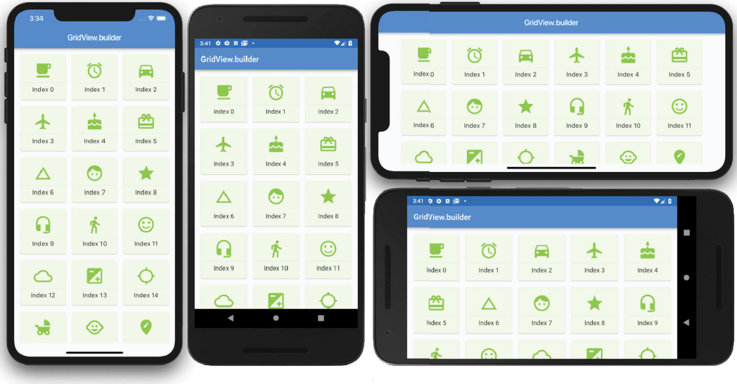

HOW IT WORKS
The GridView.builder constructor takes an itemCount and uses the itemBuilder to build a widget for each child record. Each child widget is added to the widget tree with the appropriate values. As each child widget is added, you can customize the rows according to app specs. In this example, you used
a Card to give each Grid Row item a nice look and used an InkWell to use the Material Design tap animation and the onTap property. The InkWell child is a Column, and its children items show an Icon and Text.

USING THE STACK
The Stack widget is commonly used to overlap, position, and align widgets to create a custom look. A good example is a shopping cart with the number of items to purchase on the upper-right side. The Stack children list of the widget is either positioned or nonpositioned. When you use a Positioned widget, each child widget is placed at the appropriate location.
The Stack widget resizes itself to accommodate all of the nonpositioned children. The nonpositioned children are positioned to the alignment property (Top­Left or Top­Right depending on the left-to- right or right-to-left environment). Each Stack child widget is drawn in order from bottom to top, like stacking pieces of paper on top of each other. This means the first widget drawn is at the bottom of the Stack, and then the next widget is drawn above the previous widget and so on. Each child widget is positioned on top of each other in the order of the Stack children list. The RenderStack class handles the stack layout.
To align each child in the Stack, you use the Positioned widget. By using the top, bottom, left, and right properties, you align each child widget within the Stack. The height and width proper- ties of the Positioned widget can also be set (Figure 9.6).

FIGURE 9.6: Stack layout showing Image and Text widgets stacked over the background image

You’ll also learn how to implement the FractionalTranslation class to position a widget fraction- ally outside the parent widget. You set the translation property with the Offset(dx, dy) (double type value for x-and y-axis) class that’s scaled to the child’s size, resulting in moving and positioning the widget. For example, to show a favorite icon moved a third of the way to the upper right of the parent widget, you set the translation property with the Offset(0.3, ­0.3) value.
The following example (Figure 9.7) shows a Stack widget with a background image, and by using the FractionalTranslation class, you set the translation property to the Offset(0.3, ­0.3) value, placing the star icon one-third to the right of the x-axis and a negative one-third (move icon upward) on the y-axis.
Stack(
children: <Widget>[
Image(image: AssetImage('assets/images/dawn.jpg')), Positioned(

top: 0.0,
right: 0.0,
child: FractionalTranslation( translation: Offset(0.3, ­0.3), child: CircleAvatar(
child: Icon(Icons.star),
),
),
),
Positioned(/* Eagle Image */), Positioned(/* Bald Eagle */),
],
),

FIGURE 9.7: FractionalTranslation class showing favorite icon moved to the upper right

TRY IT OUT Creating the Stack App
In this example, the Stack widget children list of widgets lays out a background Image and two Positioned widgets with CircleAvatar and Text widgets. To show an alternate layout, you use the same previous Stack layout and add a Positioned widget with the child property as a Fractional­ Translation class to show a CircleAvatar pinned to the upper-right corner halfway outside the Stack. A ListView is used to create the sample list, and each row displays an alternate Stack widget.
- Create a new Flutter project and name it ch9_stack. Again, follow the instructions in Chapter 4. For this project, you need to create the pages, widgets, and assets/images folders. Create the Home Class as a StatelessWidget since your data does not require changes.
- Open the pubspec.yaml file to add resources. In the assets section, add the assets/ images/ folder.

# To add assets to your application, add an assets section, like this: assets:
­ assets/images/

- Click the Save button, and depending on the editor you are using, it automatically runs the flutter packages get, and once finished, it will show a message of Process finished with exit code 0. If it does not automatically run the command for you, open the Terminal window (located at the bottom of your editor) and type flutter packages get.
- Add the folder assets and subfolder images at the project’s root, and then copy the dawn.jpg, eagle.jpg, lion.jpg, and tree.jpg files to the images folder.
- Open the home.dart file and add to the body a SafeArea with ListView.builder() as a child. body: SafeArea(
child: ListView.builder(),
),

- Add to the top of the file the import statement for the stack.dart and stack_favorite.dart
widget classes that you’ll create next.
import 'package:flutter/material.dart';
import 'package:ch9_stack/widgets/stack.dart';
import 'package:ch9_stack/widgets/stack_favorite.dart';

- Add to the ListView.builder the itemCount argument with a value set to 7. For this example, you specify to list seven rows of data. For the itemBuilder callback, it passes the BuildContext and the widget index as an int value.
With each Stack layout, you alternate between them by checking whether the index value is even or odd and then call the widget classes StackWidget() and StackFavoriteWidget(), respectively.
I wanted to show that you can customize which widgets you present to the user. Let’s say you have an app that you distribute as freeware and every ten records you show an advertisement or a tip embedded in the list. This technique is not as intrusive as a pop-up while the user views records.
body: SafeArea(
child: ListView.builder( itemCount: 7,
itemBuilder: (BuildContext context, int index) { if (index.isEven) {
return const StackWidget();
} else {
return const StackFavoriteWidget();
}
},
),
),

- Create a new Dart file in the widgets folder. Right-click the widgets folder and then select New ➪
Dart File, enter stack.dart, and click the OK button to save.
- Import the material.dart library, add a new line, and then start typing st; the autocompletion help opens, where you can select the stless (StatelessWidget) abbreviation and give it a name of StackWidget.

- Modify the StackWidget widget class to return a Stack. The Stack children list of widgets consists of an Image with the AssetImage tree.jpg.
- Add a Positioned widget with bottom and left properties with a value of 10.0. The child is a CircleAvatar with a radius of 48.0 and has the backgroundImage property set to AssetImage lion.jpg.
- Add another Positioned widget with bottom and right properties with a value of 16.0. The child is a Text widget with a string value of Lion, and it has a style property with a TextStyle class with a fontSize set to 32.0 pixels, color set to white30, and fontWeight set to bold.
import 'package:flutter/material.dart';

class StackWidget extends StatelessWidget { const StackWidget({
Key key,
}) : super(key: key);

@override
Widget build(BuildContext context) { return Stack(
children: <Widget>[ Image(
image: AssetImage('assets/images/tree.jpg'),
),
Positioned( bottom: 10.0,
left: 10.0,
child: CircleAvatar( radius: 48.0,
backgroundImage: AssetImage('assets/images/lion.jpg'),
),
),
Positioned( bottom: 16.0,
right: 16.0, child: Text( 'Lion',
style: TextStyle( fontSize: 32.0,
color: Colors.white30, fontWeight: FontWeight.bold,
),
),
),
],
);
}
}
- Create a new Dart file in the widgets folder. Right-click the widgets folder and then select New ➪
Dart File, enter stack_favorite.dart, and click the OK button to save.
- Import the material.dart library, add a new line, and then start typing st; autocompletion help opens, so select the stless (StatelessWidget) abbreviation and give it a name of StackFavoriteWidget.

- Modify the StackFavoriteWidget widget class to return a Container. Use a Container to set color to black87 and for the child use a Padding with EdgeInsets.all(16.0). This will create a dark frame effect around the Stack.
- For the Stack children list of widgets, add an Image set to AssetImage dawn.jpg.
- Add a Positioned widget with bottom and right properties with the values 0.0. The child is a FractionalTranslation class with a translation property of Offset(0.3,­0.3). The child is a CircleAvatar, and by using the Offset, it shows it pinned to the upper-right corner halfway outside of the Stack.
- Add a Positioned widget with bottom and right properties with a value of 10.0. The child is a
CircleAvatar with a radius of 48.0 and backgroundImage with the AssetImage eagle.jpg.
- Add another Positioned widget with bottom and right properties that have values of 16.0. The child is a Text widget with a string value of Bald Eagle, and it has a style property with a TextStyle with fontSize set to 32.0 pixels, color set to white30, and fontWeight set to bold.
import 'package:flutter/material.dart';

class StackFavoriteWidget extends StatelessWidget { const StackFavoriteWidget({
Key key,
}) : super(key: key);

@override
Widget build(BuildContext context) { return Container(
color: Colors.black87, child: Padding(
padding: const EdgeInsets.all(16.0), child: Stack(
children: <Widget>[ Image(
image: AssetImage('assets/images/dawn.jpg'),
),
Positioned( top: 0.0,
right: 0.0,
child: FractionalTranslation( translation: Offset(0.3, ­0.3), child: CircleAvatar(
radius: 24.0,
backgroundColor: Colors.white30, child: Icon(
Icons.star, size: 24.0,
color: Colors.white,
),
),
),
),
Positioned( bottom: 10.0,

right: 10.0,
child: CircleAvatar( radius: 48.0,
backgroundImage: AssetImage('assets/images/eagle.jpg'),
),
),
Positioned( bottom: 16.0,
left: 16.0, child: Text(
'Bald Eagle', style: TextStyle(
fontSize: 32.0,
color: Colors.white30, fontWeight: FontWeight.bold,
),
),
),
],
),
),
);
}
}
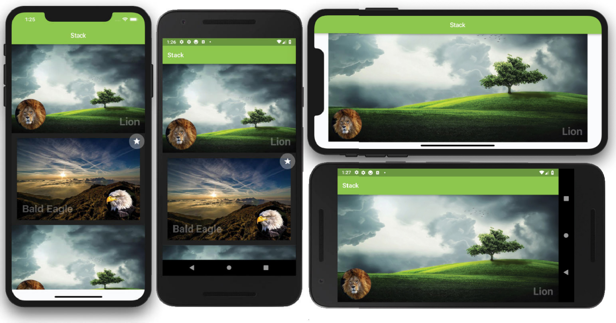

HOW IT WORKS
The Stack takes a children list of widgets and sizes itself to accommodate all of the nonpositioned widgets. When you use nonpositioned widgets in the Stack, they are automatically positioned to the setting of alignment (Top­Left or Top­Right depending on environment). Each Stack child widget is drawn in order from bottom to top, meaning each child widget is positioned on top of each other.

Using the Positioned widget allows each child widget to be aligned by using the top, bottom, left, and right properties. You learned how to position the favorite icon to the upper right of the parent widget by using the FractionalTranslation class’s translation property with the Offset(0.3,­03) value.

CUSTOMIZING THE CUSTOMSCROLLVIEW WITH SLIVERS
The CustomScrollView widget creates custom scrolling effects by using a list of slivers. Slivers are a small portion of something larger. For example, slivers are placed inside a view port like the CustomScrollView widget. In the previous sections, you learned how to implement the ListView
and GridView widgets separately. But what if you needed to present them together in the same list? The answer is that you can use a CustomScrollView with the slivers property list of widgets set to the SliverSafeArea, SliverAppBar, SliverList, and SliverGrid widgets (slivers). The order in which you place them in the CustomScrollView slivers property is the order in which they are rendered. Table 9.1 shows commonly used slivers and sample code.

TABLE 9.1: Slivers

SLIVER | DESCRIPTION | CODE
SliverSafeArea | Adds padding to avoid the device notch usually located on the top of the screen | SliverSafeArea(  sliver: SliverGrid(),  )
SliverAppBar | Adds an app bar | SliverAppBar( expandedHeight: 250.0,  flexibleSpace: FlexibleSpaceBar( title: Text('Parallax'),  ),  )
SliverList | Creates a linear scrollable list of widgets | SliverList(  delegate: SliverChildListDelegate( List.generate(3, (int index) {  return ListTile();  }),  ),  )
SliverGrid | Displays tiles of scrollable widgets in a grid format | SliverGrid(  delegate: SliverChildBuilderDelegate( (BuildContext context, int  index) {  return Card();  },  childCount: _rowsCount,  ),  gridDelegate: SliverGridDelegateWithF ixedCrossAxisCount(crossAxisCount: 3),  )

The SliverList and SliverGrid slivers use delegates to build the list of children explicitly or lazily. An explicit list builds all of the items first then displays them on the screen. A lazily built list only builds the visible items on the screen and when the user scrolls the next visible items are built (lazily) resulting in better performance. The SliverList has a delegate property and the SliverGrid has a delegate and a gridDelegate property.
The SliverList and SliverGrid delegate property can use the SliverChildListDelegate to build an explicit list or use the SliverChildBuilderDelegate to lazily build the list. The SliverGrid has an additional gridDelegate property to specify the size and position of the grid tiles. Specify the gridDelegate property with the SliverGridDelegateWithFixed­ CrossAxisCount class to create a grid layout with a fixed number of tiles for the cross axis;
for example, show three tiles across. Specify the gridDelegate property with the SliverGrid­ DelegateWithMaxCrossAxisExtent class to create a grid layout with tiles that have a maxi- mum cross-axis extent, the maximum width of each tile; for example, 150.0 pixels maximum width for each tile.
Table 9.2 shows the SliverList and SliverGrid delegates to help you build lists.

TABLE 9.2: Sliver Delegates

SLIVER | DESCRIPTION | CODE
SliverList | SliverChildListDelegate builds a list of known number of rows (explicit).  SliverChildBuilderDelegate lazily builds a list of unknown number of rows. | SliverList( delegate:  SliverChildListDelegate(<Widget>[ ListTile(title: Text('One')), ListTile(title: Text('Two')), ListTile(title: Text('Three')),  ]),  )
 |  | or
SliverList(
delegate: SliverChildListDelegate( List.generate(30, (int index) {
return ListTile();
}),
),
)
 |  | or
SliverList(
delegate: SliverChildBuilderDeleg ate((BuildContext context,
int index) {
return ListTile();
},
childCount: _rowsCount,
),
)

SLIVER | DESCRIPTION | CODE
SliverGrid | SliverChildListDelegate  builds an explicit list. SliverChildBuilderDelegate lazily builds a list of unknown  number of tiles. The gridDelegate property controls the position and size of the children widgets. | SliverGrid(  delegate: SliverChildListDelegate­ (<Widget>[  Card(),  Card(),  Card(),  ]),  gridDelegate: SliverGridDelegateWithFixedCrossAxis­ Count(crossAxisCount: 3),  )
 |  | or
SliverGrid(
delegate: SliverChildListDelegate( List.generate(30, (int index) {
return Card();
}),
),
gridDelegate: SliverGridDelegateWithFixedCross­ AxisCount(crossAxisCount: 3),
)
 |  | or
SliverChildBuilderDelegate( (BuildContext context,
int index) {
return Card();
},
childCount: _rowsCount,
),
gridDelegate: SliverGridDelegateWithFixedCross­
AxisCount(crossAxisCount: 3),
)

The SliverAppBar widget can have a parallax (Figure 9.8) effect by using the expandedHeight and flexibleSpace properties. The parallax effect scrolls a background image slower than the content in the foreground. If you need to show the CustomScrollView initially scrolled at a particular position, use a controller and set the ScrollController.initialScrollOffset property. For example, you would set the initialScrollOffset by initializing the controller = ScrollController(ini­ tialScrollOffset: 10.0).

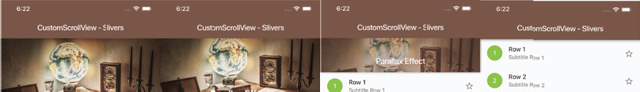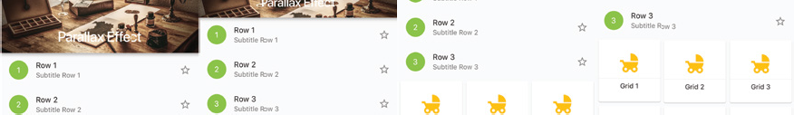
FIGURE 9.8: SliverAppBar scrolling parallax effect

TRY IT OUT Creating the CustomScrollView Slivers App
In this example, the CustomScrollView children list of widgets contains a SliverAppBar, SliverList, SliverSafeArea, and SliverGrid. The SliverAppBar widget uses the flexibleSpace with a back- ground Image that has a parallax effect while scrolling. The SliverList generates three items with the List.generate constructor. To account for the device notch, you use a SliverSafeArea to wrap the SliverGrid, and you generate 12 (sample value can be more or less) items.
- Create a new Flutter project and name it ch9_customscrollview_slivers; you can follow the instructions in Chapter 4. For this project, you only need to create the pages and assets/images folders. Create the Home Class as a StatelessWidget since the data does not require changes.
- Open the pubspec.yaml file to add resources. In the assets section, add the assets/ images/ folder.
# To add assets to your application, add an assets section, like this: assets:
­ assets/images/

- Click the Save button, and depending on the editor you are using, it automatically runs flutter packages get. Once finished, it will show a message of Process finished with exit code 0. If it does not automatically run the command for you, open the Terminal window (located at the bottom of your editor) and type flutter packages get.
- Add the folder assets and subfolder images at the project’s root and then copy the desk.jpg file to the images folder.
- Open the home.dart file and add to the body a CustomScrollView(). For this project, set the
AppBar elevation property to 0.0 because you enable the SliverAppBar shadow instead.
return Scaffold( appBar: AppBar(
title: Text('CustomScrollView ­ Slivers'), elevation: 0.0,
),

body: CustomScrollView( slivers: <Widget>[
],
),
);

- Add to the top of the file the import statement for the sliver_app_bar.dart, sliver_list. dart, and sliver_grid.dart widget classes that you’ll create next.
import 'package:flutter/material.dart';
import 'package:ch9_customscrollview_slivers/widgets/sliver_app_bar.dart'; import 'package:ch9_customscrollview_slivers/widgets/sliver_list.dart'; import 'package:ch9_customscrollview_slivers/widgets/sliver_grid.dart';

- Add calls to the SliverAppBarWidget(), SliverListWidget(), and SliverGridWidget() widget classes to the CustomScrollView() slivers property. Make sure the calls to the widget classes use the const keyword to take advantage of caching for performance gain.
return Scaffold( appBar: AppBar(
title: Text('CustomScrollView ­ Slivers'), elevation: 0.0,
),
body: CustomScrollView( slivers: <Widget>[
const SliverAppBarWidget(), const SliverListWidget(), const SliverGridWidget(),
],
),
);

- Create a new Dart file in the widgets folder. Right-click the widgets folder and then select New ➪
Dart File, enter sliver_app_bar.dart, and click the OK button to save.
- Import the material.dart library, add a new line, and then start typing st; the autocompletion help opens, so select the stless (StatelessWidget) abbreviation and give it a name of SliverAppBarWidget.
- Modify the SliverAppBarWidget widget class to return a SliverAppBar.
- To show a shadow at the bottom of the bar, set the forceElevated property to true.
- To create a parallax effect while scrolling, set expandedHeight to 250.0 pixels and flexible­ Space to FlexibleSpaceBar.
- For the FlexibleSpaceBar background property, use the Image widget with the desk.jpg file and set fit to BoxFit.cover.
import 'package:flutter/material.dart';

class SliverAppBarWidget extends StatelessWidget { const SliverAppBarWidget({
Key key,
}) : super(key: key);

@override
Widget build(BuildContext context) { return SliverAppBar(
backgroundColor: Colors.brown, forceElevated: true, expandedHeight: 250.0, flexibleSpace: FlexibleSpaceBar(
title: Text( 'Parallax Effect',
),
background: Image(
image: AssetImage('assets/images/desk.jpg'), fit: BoxFit.cover,
),
),
);
}
}
- Create a new Dart file in the widgets folder. Right-click the widgets folder and then select New ➪
Dart File, enter sliver_list.dart, and click the OK button to save.
- Import the material.dart library, add a new line, and then start typing st; the autocompletion help opens, so select the stless (StatelessWidget) abbreviation and give it a name of SliverListWidget.
- Modify the SliverListWidget widget class to return a SliverList. For the SliverList del­ egate property, pass the SliverChildListDelegate.
- Use the List.generate constructor to build your sample data list. The constructor takes two arguments: the length of the list and the index. Return a ListTile with a leading CircleAvatar with the child as a Text widget with string interpolation set with ${index + 1}.
- Also, set the ListTile title, subtitle, and trailing properties.
import 'package:flutter/material.dart';

class SliverListWidget extends StatelessWidget { const SliverListWidget({
Key key,
}) : super(key: key);

@override
Widget build(BuildContext context) { return SliverList(
delegate: SliverChildListDelegate( List.generate(3, (int index) {
return ListTile( leading: CircleAvatar(
child: Text("${index + 1}"), backgroundColor: Colors.lightGreen, foregroundColor: Colors.white,
),
title: Text('Row ${index + 1}'),

subtitle: Text('Subtitle Row ${index + 1}'), trailing: Icon(Icons.star_border),
);
}),
),
);
}
}
- Create a new Dart file in the widgets folder. Right-click the widgets folder and then select New ➪
Dart File, enter sliver_grid.dart, and click the OK button to save.
- Import the material.dart library, add a new line, and then start typing st; the autocompletion help opens, so select the stless (StatelessWidget) abbreviation and give it a name of SliverGridWidget.
- Modify the SliverGridWidget widget class to return a SliverSafeArea. Since the SliverGrid does not handle the device notch automatically, you wrap it in a SliverSafeArea. The SliverGrid delegate property is a SliverChildBuilderDelegate taking the BuildContext and int index.
- From the SliverChildBuilderDelegate, return a Card with the child as a Column. The Column
children list of Widget has Icon, Divider, and Text widgets.
- For the childCount property, pass 12 representing how many items the builder creates. The gridDelegate property is set to SliverGridDelegateWithFixedCrossAxisCount(cross­ AxisCount: 3) showing three tiles.
import 'package:flutter/material.dart';

class SliverGridWidget extends StatelessWidget { const SliverGridWidget({
Key key,
}) : super(key: key);

@override
Widget build(BuildContext context) { return SliverSafeArea(
sliver: SliverGrid(
delegate: SliverChildBuilderDelegate( (BuildContext context, int index) {
return Card( child: Column(
mainAxisAlignment: MainAxisAlignment.center, children: <Widget>[
Icon(Icons.child_friendly, size: 48.0, color: Colors.amber,), Divider(),
Text('Grid ${index + 1}'),
],
),
);
},
childCount: 12,
),
gridDelegate:

SliverGridDelegateWithFixedCrossAxisCount(crossAxisCount: 3),
),
);
}
}
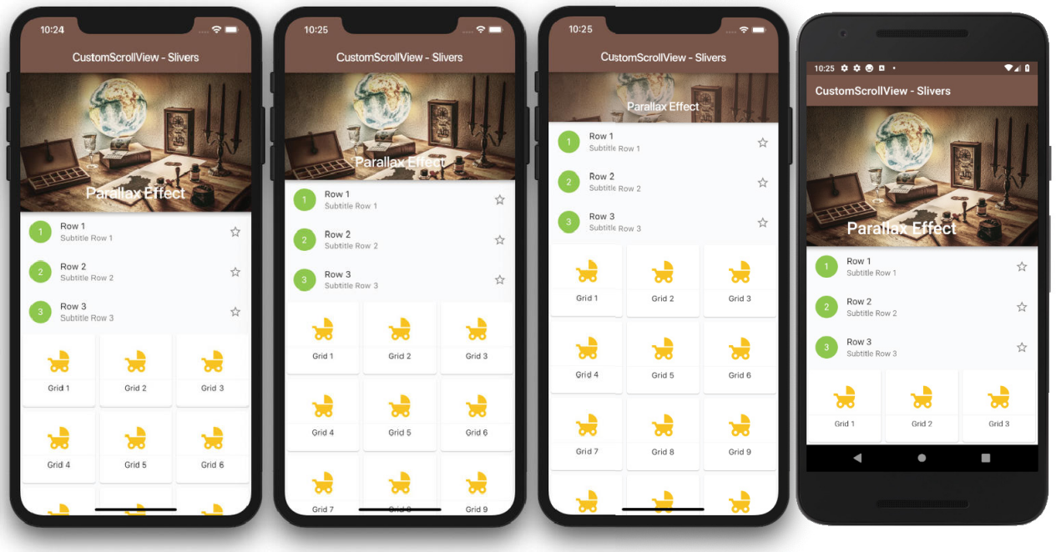

This allows you to create custom scrolling effects by using a list of slivers widgets like a SliverSafeArea, SliverAppBar, SliverList, SliverGrid, and more.

Card:
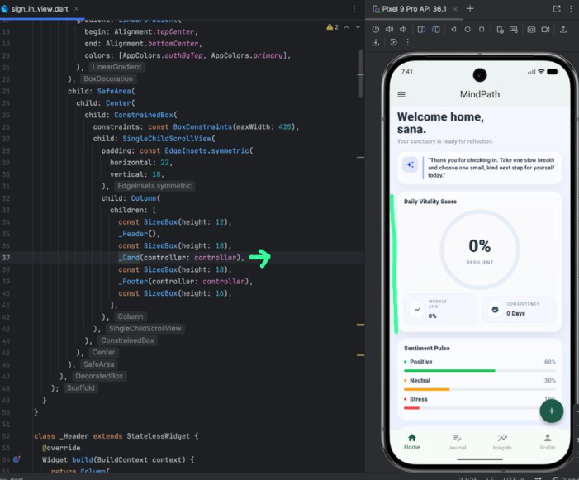
Grid:
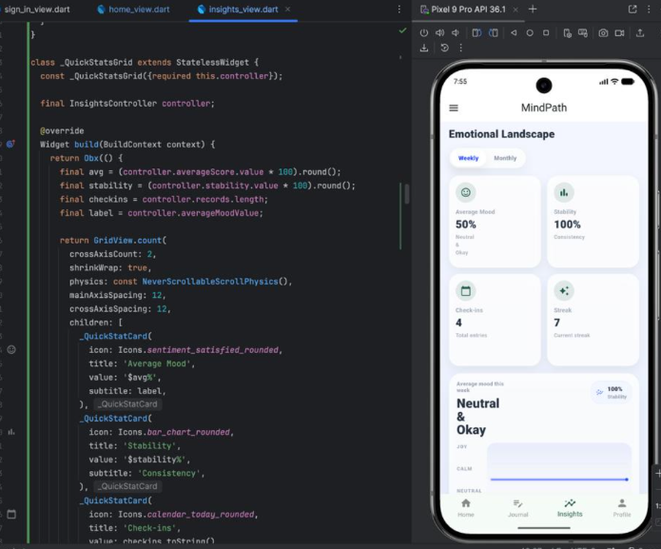
Sliver:
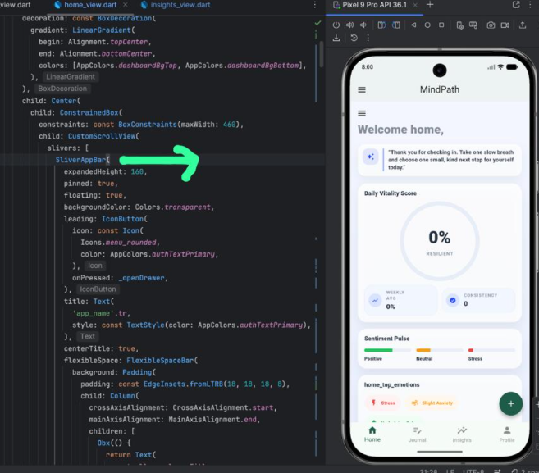
lists:
